Assignment No: 7

Write a code skeleton in java from class diagram.

Class Diagram Utility Store

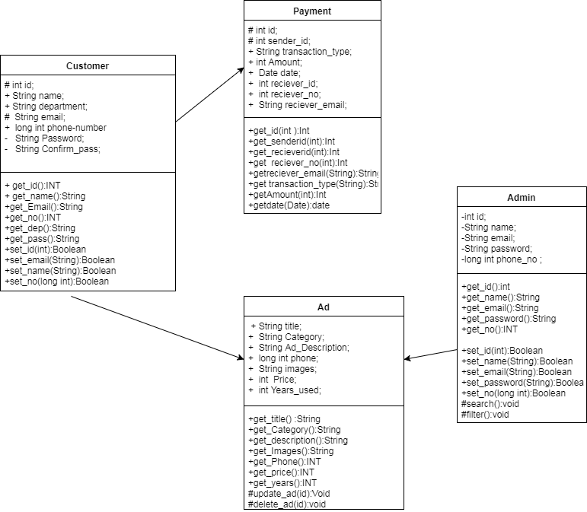

1. Customers

Public class Customers

{

public static void main()

{

protected int id;

public String name;

public String department;

protected string email;

public long int phone-number

private String Password;

private String Confirm_pass;

public int get_id(){ }

public String get_name(){ }

public String get_Email(){ }

public int get_no(){ }

public String get_dep(){ }

public String get_pass(){ }

boolean set_id(int) { }

Boolean set_email(String) { }

Boolean set_name(String) { }

Boolean set_no(long int) { }

Boolean set_dep(String) { }

Boolean set_password(String) { }

void update_profile(String ,String)

{

}

void update_password(String,String)

{

}

}

}

2. Ads

public class Ads

{

public static void main(String args[])

{

public String title;  
 public String Category;  
 public String Ad_Description;  
 public long int phone;  
 public String images;  
 public int Price;  
 public int Years_used;

public String get_title() { }  
 public String get_Category() { }  
 public String get_description() { }  
 public String get_Images() { }  
 public Int get_Phone() { }  
 public Int get_price() { }  
 public Int get_years() { }  
 void update_ad(id) { }  
 void delete_ad(id) { }  
 public boolean set_id(int) { }  
 public boolean set_Category(String) { }  
 public boolean set_description(String) { }  
 public boolean set_Images(String) { }  
 public boolean set_Price(int) { }  
 public boolean set_Years(date) { }  
 Void submit_ad() { }

}

}

3. Payment:-

public class Payment

{

public static void main()

{

protected int id;  
 protected int sender_id;  
 public String transaction_type;   
 public int Amount;  
 public Date date;  
 public int reciever_id;  
 public int reciever_no;  
 public String reciever_email;

public Int get_id(int ) { }  
 public Int get_senderid(int){ }  
 public Int get_recieverid(int){ }  
 public Int get  reciever_no(int){ }  
 public String get reciever_email(String){ }  
 public String get transaction_type(String){ }  
 public Int get Amount(int){ }  
 public date get date(Date){ }  
  
 public Boolean set_id(){ }  
 public Boolean set_senderid(){ }  
 public Boolean set_reciverid(){ }  
 public Boolean set_reciver_no(){ }  
 public Boolean set_reciverver_email(){ }  
 public Boolean set_trans_type(){ }  
 public Boolean set_Amount(){ }  
 public Boolean set_date(){ }

}

}

4. Admin

public class Admin

{

public static void main()

{

private int id;   
 private String name;  
 private String email;   
 private String password;  
 private long int phone_no ;

public int get_id() { }  
public string get_name(){ }  
public string get_email(){ }  
public string get_password(){ }  
public int get_no(){ }  
  
public Boolean set_id(int) { }  
public Boolean set_name(String) { }  
public Boolean set_email(String) { }  
public Boolean set_password(String) { }  
public Boolean set_no(long int) { }  
protected void search(){ }  
protected void filter(){ }

}

}